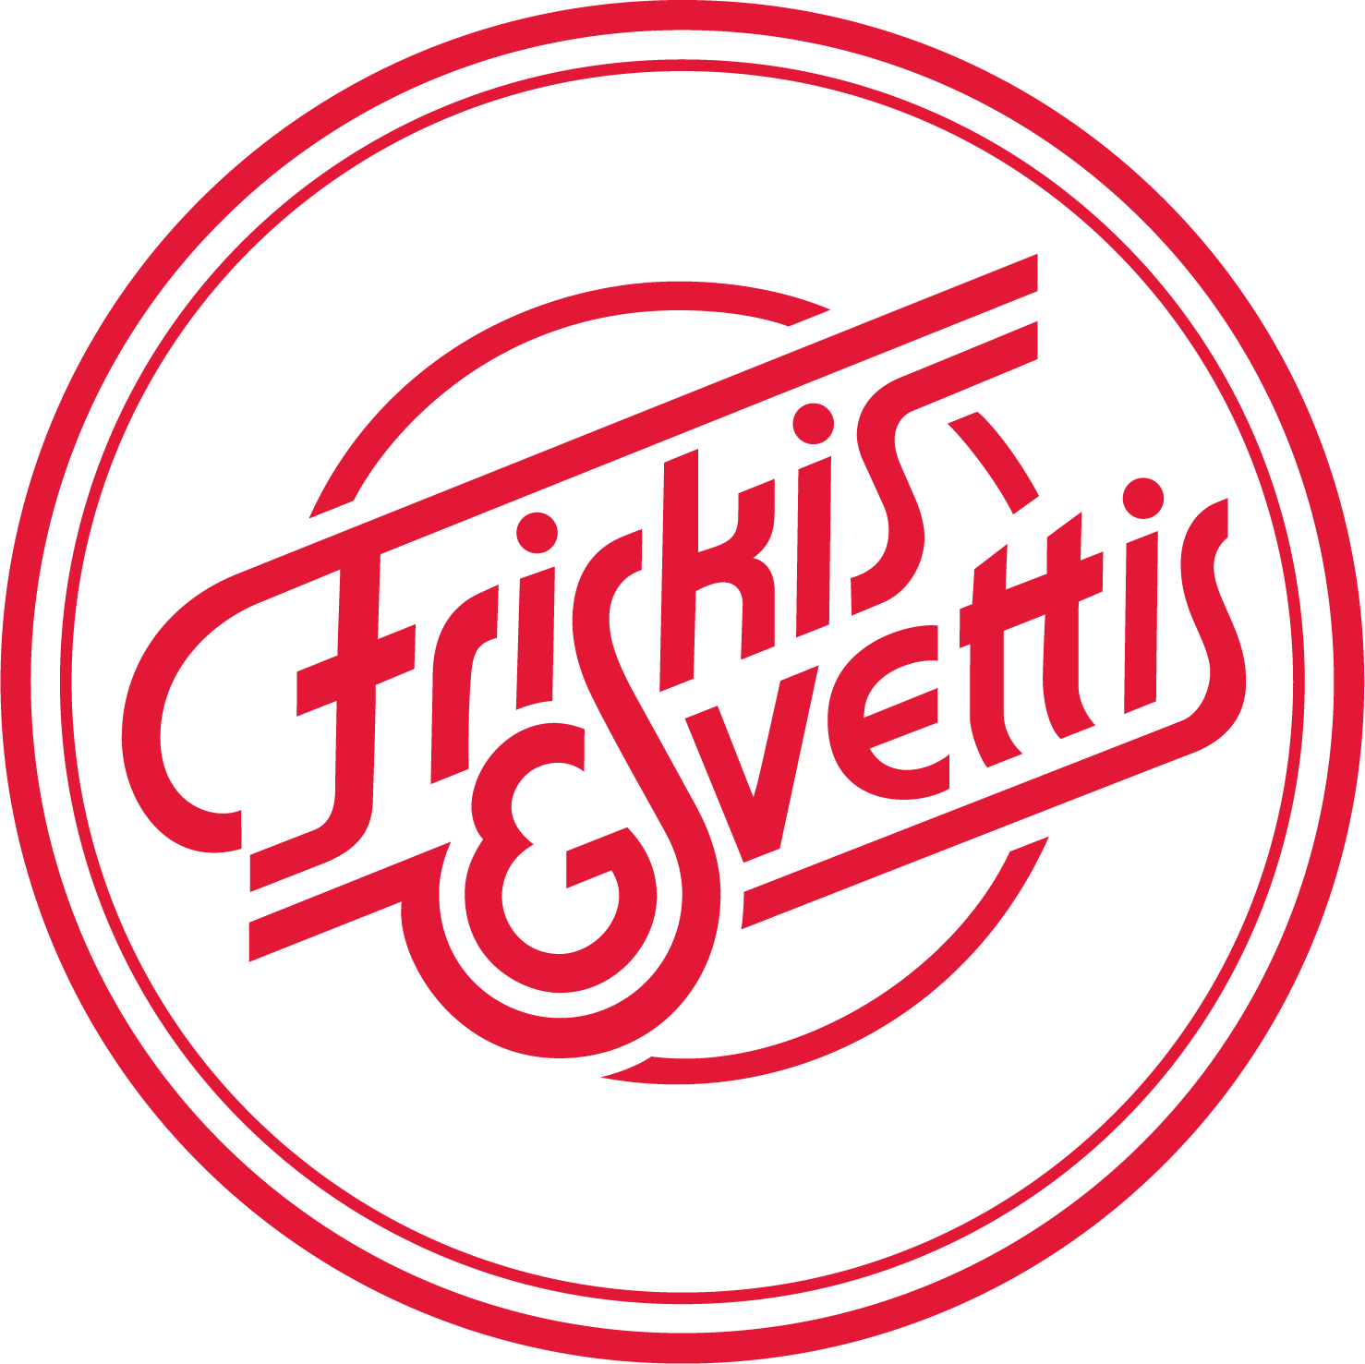

Friskis & Svettis London AGM 2019
Date: Saturday 6th April 2019
Time: 12.45pm
Venue: The Royal Oak, 74-76 York Street, London, W1H 1QN

Minutes of the AGM for the financial year 2018

1. Opening of the Annual General Meeting
Chairman Hugh Governey opens the AGM.

2. Election of Chairman and Secretary of the AGM
Hugh Governey is elected as Chairman of the AGM.
Maria Klavir is elected as Secretary of the AGM.

3. Kia Duncan is elected to approve the minutes.

4. Confirmation of electoral register for meeting
The following persons presented themselves as present and the electoral register for the meeting was composed of:
Hugh Governey
Kia Duncan
Brigid Bryan
Ian Naldrett
Adam Redzej
Emma Bosch
Maria Klavir

5. The meeting has been advertised in the correct way, both in the Facebook group and in connection to several classes.

6. Confirmation of the agenda
The agenda is confirmed.

7. Approval of the minutes from previous year’s AGM
The minutes from last year’s AGM are approved.

8. Presenting and putting to the vote the board’s Annual report, Income statement and Balance Sheet from the financial year of 2018 (see Appendix I)
Hugh Governey presents the Annual Report and Kia Duncan presents the financial statement for 2018.

In June 2018 2 classes at YMCA were removed due to too high rents and not enough participants attending. In September 2018 a Saturday class was added at Seymour Leisure Centre with the hope to add new members mainly by the close proximity to the International Community School, the Swedish Church and the Swedish Embassy.

A new pricing strategy as of 1st September was suggested and approved.
Clapham: PAYG £10, 10 Card £60
YMCA and Seymour: PAYG £6 (/£8 from January 2019), 10 Card £50 (/£60 from January 2019).

The costs have been cut substantially compared to 2017 by removing the instructor´s remuneration during 2018 and cutting the number of classes at YMCA.

The fixed expenses such as instructor´s insurances, music license and membership fees to Riks has stayed around the same compared to 2017.

The total income from sold cards and one-off tickets has decreased by 58% compared to 2017. This is most likely a result of cutting classes during the beginning of 2018.

In 2018 we took on average of £45 per class, each class cost £55 to run, resulting in a loss of £10 per class. However, in Clapham we have gone from a break-even to a profit by £10 per class during 2018. At YMCA we have gone from a loss of -£21 to a profit of £3 per class after removing two classes/week. At Seymour, where we started to run classes in September 2018, the loss has been -£26. The total loss for the year is £1,431, which means we have managed to cut the costs by around 50% compared to 2017.

Following price increases, running 1 YMCA class only and decision not to continue the Seymour class we are expecting to see a positive change and starting to make a profit from January 2019.

The board’s Annual report, Income statement and Balance Sheet from the financial year of 2018 are approved.

9. Presenting and putting to the vote the Auditor’s report about the board’s administration during the financial year of 2018
The balance sheet and income statement are adopted and auditor Johan Wissinger gives evidence that he has approved the documents. The board is given freedom of liability.

The auditor’s report (see Appendix II) about the board’s administration during the financial year of 2018 is approved.

10. Members’ motions
No motions from the members are raised at this point.

11. Proposals from the board
Elected onto the board are:
Chairman Hugh Governey
Head of Instructors Charlotte Berning to December 2019, Maria Klavir from December 2019
Head of Hosts Brigid Bryan
Head of Marketing Maria Klavir to end of June 2019, Ian Naldrett from July 2019
Treasurer Kia Duncan

Emma Bosch and Kia Duncan are elected as Election Committee for the next year, and Brigid Bryan is elected Auditor.

12. Vote on proposed organisational structure and consequent election of a new board: Board, Finance & Election Committee
All board nominees are approved and the board elected unanimously.

13. Information about current activities within F&S London and focus for 2019 and beyond
An activity plan was discussed and the conclusion was:
- Increase the attendance at the Monday and Tuesday class, focus on high quality and good energy, and find ways of promoting the classes and the association.
- If increased numbers and better finance during H1 2019, look for other venues for H2 2019. An earlier time slot than now offered was discussed (around 6.30pm). If another weekend class, find more of a close community.
- Increase the involvement and the engagement from the whole team and the members.
- Look at if we can offer any different kind of classes that doesn´t require equipment. Main focus should still be on Jympa though.
- Offer a few outdoor events (2-3 hours long) during the Summer to increase the engagement with the members. Emma Bosch and Hugh Governey will look into this.

14. Putting to the vote the proposed activity plan for the year 2019
The proposed activity plan is approved unanimously.
Focus will be on running two classes a week well, and to keep being profitable at these classes.

15. Decision not to schedule the Seymour Place class for the Summer Term
A decision has been taken after a unanimous vote amongst the Board members to cancel the Saturday class at Seymour Leisure Centre from May 2019 since we cannot attract enough participants to cover the rent and other fixed costs. The information will be communicated on Facebook, website and after our classes.

16. Confirmation of membership fee for the financial year 2019
Current pricing is:
YMCA and Seymour: PAYG £8, 10 Card £60 (after raising the PAYG price from £6 to £8 and the 10 card from £50 to £60 in January 2019)
Clapham: PAYG £10, 10 Card £60.
The prices will be reviewed during H2 2019.

17. Any other business

New website
The new website will hopefully be launched in a 2 weeks’ time. This will allow us to keep the members better informed and hopefully more engaged. The new board will discuss how we can keep the website updated in a smooth way and who will be responsible for it.

MoveGB and ClassPass
A suggestion was brought up and agreed on, to register with one email address that all instructors and host can access. That way the hosts/instructors take responsibility to check themselves before their classes which ones will attend.

18. Closing of the Annual General Meeting
Chairman Hugh Governey closes the AGM.

APPENDIX I – FINANCIAL REPORT 2018

Financial report 2018
Prepared for the AGM 6 April 2019

Accounting principles
We book entries on an accrual basis. Long-term investments such as training of new instructors or buying music equipment for outdoor classes are expensed in the year incurred and not amortised over time. This gives a smaller annual profit for the year in which the investment was made, than if we had written the costs off over three years.

In 2018 we have taken on average £44 per class, each class costs £55 to run, resulting in a loss of £10 per class. This is a total loss of £1,428 vs £2,800 in 2017, which is encouraging development.
We continued to keep costs at a minimum in 2018.
September price increases in Clapham gave us an extra £12 in gross profit per class. The decision to move to Tuesday class only at YMCA from June resulted in a smaller gross loss per class of £10 down from £21. Seymour had a loss contribution of £14 per class. The Board decided not to renew the contract after April as the operating cost of running the class is not covered and we saw no increase in attendance (average of 5). Due to these changes we are positive that we will see a further positive trend in 2019.

 |  | Sep Price increase |  | Only Tue class - Jun
 | Clapham | Clapham | YMCA | YMCA | Seymour
Jan-Jun 2018
Income | 1,078 |  | 2,528 | 176
Venue cost | 850 |  | 3,113 | 200
 | 228 |  | - 585 | - 24
Other costs | 225 |  | 581 | 37
Total profit/(loss) | 3 |  | - 1,166 | - 61 | - |  | - 1,225
Operating profit per class | 9 |  | - 9 | - 1
Jul-Dec 2018
Income |  | 850 |  | 1,314 | 432
Venue cost |  | 532 |  | 1,256 | 672
 |  | 318 |  | 58 | - 240
Other costs |  | 222 |  | 370 | 252
Total profit/(loss) |  | 96 |  | - 312 | - 491 |  | - 707
Operating profit per class |  | 21 |  | 15 | - 14
Jan-Feb 2019
Number of classes |  | 6 |  | 8 | 6
Income |  | 460 |  | 828 | 251
Venue cost |  | 222 |  | 400 | 240
 |  | 238 |  | 428 | 11
Other costs |  | 144 |  | 192 | 144
Total profit/(loss) |  | 94 |  | 236 | - 133 |  | 197
Operating profit per class |  | 40 |  | 54 | 2

Income Statement
For the year ended 31 December 2018
 |  | 2018 | 2017
 |  | £ | £
Income:
 | Season Card | 560 | 2,660
 | 10 Card | 3,270 | 4,100
 | One-off | 2,573 | 4,396
 | Class Pass | 278 | 204
 | Move GB | 8 | 171
 | Net income from activities | 6,688 | 11,531
Cost of Sales:
 | Instructor Fee | (190) | 1,688
 | Venue Hire YMCA | 4,569
 | Venue Hire Clapham | 1,382
 | Venue Hire Seymour | 672
 | Total cost of sales | 6,433 | 12,641
 | Gross loss | 256 | (1,110)
Expenses:
 | Advertising & Marketing
 | Bank Charge | 30 | 40
 | Clothes
 | Entertainment - Staff |  | 60
 | Insurance | 479 | 367
 | New Instructor
 | Instructor - Training
 | Postage | 1 | 4
 | PPL - Music Licence | 647 | 647
 | Subscriptions & Memberships | 260 | 395
 | Internet | 220 | 149
 | Special Event | 50
 | Total Expenses | 1,687 | 1,662
 | Net operating loss | (1,431) | (2,772)
Other Income:
 | Interest Income | 3 | 3
 | Total other income | 3 | 3
 | Net loss | (1,428) | (2,768)
Friskis & Svettis London
Statement of Financial Position
As at 31st December 2018
 |  | 2018 | 2017
 |  | £ | £
Current assets
 | Trade Receivables | 98 | 1,260
 | Cash at Bank | 9,468 | 12,774
 |  | 9,566 | 14,034
Current liabilities
 | Trade Payables | (2,195) | (5,235)
Net assets |  | 7,371 | 8,799
Equity
 | Reserves | 8,799 | 11,568
 | Profit for the year | (1,428) | (2,768)
 |  | 7,371 | 8,799

London 6 April 2019
Prepared by: Approved for AGM vote:

___________________ ____________________
Kia Duncan Hugh Daniel Governey
Treasurer Chairman

Independent Auditor’s Report
I have audited the financial statements for Friskis&Svettis London for the financial years ended 31 December 2018, which comprise the income statement, balance sheet and related notes and documentation.
In my opinion, the financial statements give a true and fair view of the state of Friskis&Svettis London’s affairs as at 31 December 2018 and of its annual result for the year then ended and have been properly prepared in accordance with the Rules & Regulations of the association.
I therefore recommend that the AGM approve the accounts for financial year 2018.

______________________
Johan Wissinger
Auditor

APPENDIX II – AUDITOR´S REPORT

Ahead of the AGM, I have gone through the accounts with Kia.
I am happy to say that the bookkeeping is – as usual – well organised and in order. I would therefore recommend that the AGM approves the accounts as presented by Kia.
MY NOTES
- Positive trend:
Loss of around £1,400 in 2018 vs £2,800 in 2017, which I see as real positive progress
- Decision to increase fees and reduced classes was correct:
The decision by the AGM in 2018 to stop the running losses has paid off:
  - increasing fees from Sep 2018, and
  - reduce the number YMCA of classes
- No losses in 2H 2018
As a result of this decision, we have seen:
- Before fee changes:
Significant loss per class in 1H => £1,400 of accumulated losses in the first six months
- After fee changes implemented:
Breakeven or even a small profit per class in 2H => No additional losses in 2H 2018
- We have turned the corner
In conclusion, it looks like we have turned the corner with a breakeven or slightly positive monthly run rate from Sep 2018
- Continued focus on quality and prudent spending
I would recommend continued focus on quality classes, no free trials, and very prudent financial management in 2019, to help us continue this trend and move to profit.

Best regards,
Johan

